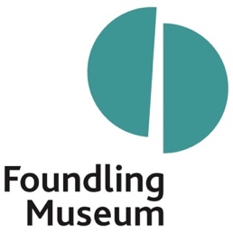

Role: | DEVELOPMENT MANAGER – INDIVIDUAL GIVING  (PATRONS & FRIENDS)
Reporting to: | Director of Development & Communications
Supervises: | None
Purpose of job: | To lead the day-to-day delivery and growth of the Museum’s Patrons and Friends programme, taking it to the next level. The role will also support wider Individual Giving activity, including general donations and lower-level appeals, and contribute to wider fundraising priorities in line with team priorities, offering the opportunity to broaden fundraising skills.  Working closely with the Director of Development & Communications, team colleagues and colleagues across the Museum, you will help strengthen unrestricted income and deepen supporter relationships. You will play a key role in growing and refreshing our supporter programmes – increasing recruitment, improving retention and helping build a stronger future donor pipeline.  This is a role for someone who enjoys taking responsibility, spotting opportunities and making change happen while remaining closely involved in delivery. In return, you will gain broader fundraising experience and make a visible contribution within a small, ambitious museum.
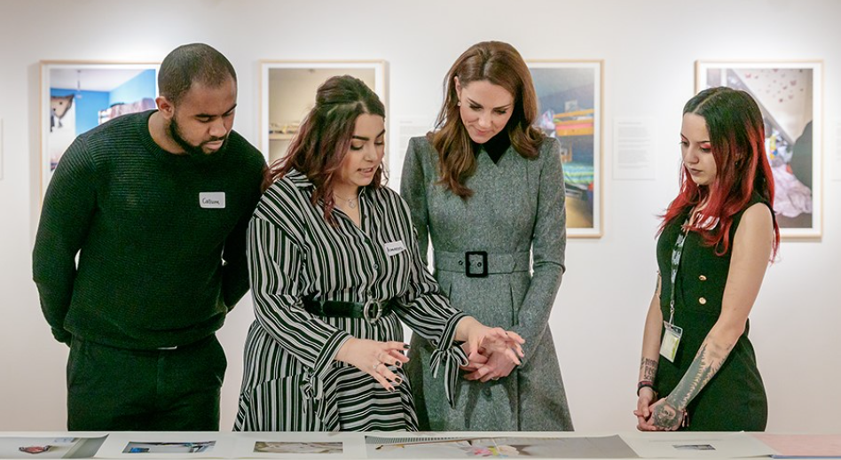
Our Royal Patron, HRH The Princess of Wales, being shown around Bedrooms of London by graduates of the Museum’s pioneering
training programme for care-experienced young adults.

Working pattern: | Full Time
Contract: | Permanent
Salary:  Location: | £35,000 – £37,000 per annum, dependent on experience  Hybrid – Up to 40% working from home in a typical working week

WHO WE ARE LOOKING FOR
We are looking for a confident, organised and relationship-focused fundraiser. You will have strong hands-on experience of managing and growing Patrons, Friends, membership or similar supporter programmes, alongside the energy and creativity needed to shape the next phase of Individual Giving at the Foundling Museum.

The role will suit someone already taking significant responsibility for recruitment, renewals, stewardship and income growth, who is ready to broaden their skills in Individual Giving and wider fundraising. You will strengthen donor pipelines, identifying supporters with the potential to deepen their engagement.

KEY CRITERIA FOR SUCCESS
After 6 months, the successful candidate will have:

- Established themselves as a trusted and valued colleague within the Museum team, working confidently with colleagues and contributing positively to the developing Development and Communications culture
- Taken confident responsibility for the day-to-day delivery of the Patrons programme and Friends scheme, with clear renewal, stewardship and supporter communications processes in place
- Identified early opportunities to increase recruitment, improve retention and grow income from Patrons, Friends and other Individual Giving activities, as well as supporting other fundraising activities
- Strengthened the Museum’s Individual Giving foundations by improving Beacon records, donation processes, supporter journeys, communications and day-to-day ways of working.

KEY RESPONSIBILITIES

- Patrons and Friends
- Take responsibility for the day-to-day delivery of the Museum’s Patrons programme and Friends scheme, including renewals, administration, communications and coordination
- Build warm, credible relationships with Patrons, Friends and prospective supporters, acting as a key point of contact and ambassador for these schemes
- Drive recruitment, retention and ambitious income growth across Patrons and Friends, with a clear focus on expanding reach, increasing income and strengthening engagement
- Ensure Patron and Friend benefits are delivered consistently and warmly
- Keep both schemes fresh, relevant and connected to the Museum’s wider case for support

- Wider Individual Giving
- Support and develop wider Individual Giving activity, including donations, lower-level appeals and top-up or repeat giving
- Use ideas, data and insight to grow unrestricted income and improve recruitment, retention, supporter journeys and giving opportunities
- Draft clear, engaging supporter communications, acknowledgement letters and fundraising messages that build affinity, loyalty and giving
- Stewardship, events and supporter experience
- Support and lead cultivation, stewardship and fundraising events for Patrons, Friends and wider donors, drawing on the Museum’s public programme and tailored opportunities
- Help ensure every supporter interaction is well prepared, reflects the Museum’s values and leaves donors feeling valued, informed and connected to the Museum’s work
- CRM (Beacon), administration and reporting
- Ensure Beacon supports effective fundraising by maintaining accurate, reliable and useful data
- Oversee the effective processing of donations, memberships, renewals and acknowledgements, ensuring a consistently high-quality supporter experience
- Use reports, lists and updates on income, renewals, activity and supporter engagement to strengthen planning, tracking and decision-making.

- Wider Development contribution
- Contribute to wider fundraising activity where this supports team priorities, including trusts and foundations, events, corporate partnerships and other Development priorities as needed, offering useful personal development opportunities
- Work collaboratively with colleagues across Finance, Programming, Communications and other teams to support joined-up fundraising and supporter engagement
- Carry out other reasonable duties appropriate to the role and the needs of a small museum team

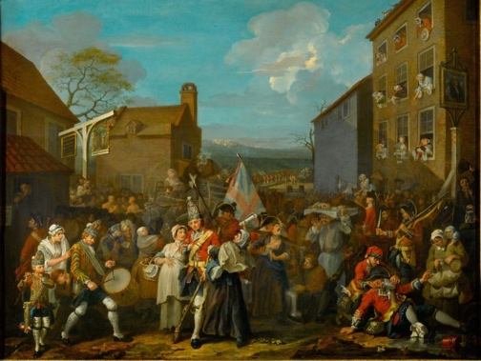
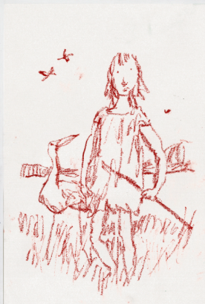
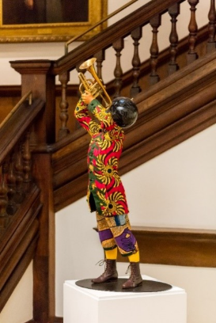
From left: William Hogarth, March of the Guards to Finchley, 1750; Quentin Blake, Children with Birds and Dogs, 2019, donated by the artist; Yinka Shonibare CBE, Trumpet Boy, 2010, acquired with support from Art Fund, the ACE/V&A Collection Purchase Grant and individual supporters. © The artists.

PERSON SPECIFICATION

a) Experience and knowledge

Essential
- Experience of working in fundraising, membership, development or a closely related supporter-facing role
- Experience of managing Patrons, Friends, membership or similar supporter programmes, including recruitment, renewals, stewardship and income growth
- Experience of supporter stewardship, renewals, donor communications and relationship management
- Experience of using a database or CRM system to manage supporter records, donations, memberships, renewals and acknowledgements accurately
- Experience of supporting or delivering events, mailings or supporter communications
- Experience of working collaboratively across teams and contributing beyond a core programme area where this supports shared priorities.

Desirable
- Experience of working in a museum, gallery, arts, heritage or charitable organisation
- Experience of helping to increase unrestricted income through Friends, Patrons, annual giving, general donations, lower-level appeals or membership schemes
- Experience of other income streams and a willingness to learn, develop and grow
- Experience of writing supporter-focused fundraising copy, appeals or stewardship communications
- Knowledge of Gift Aid, data protection and good fundraising practice

b) Skills, abilities and attitudes
- Excellent interpersonal and written communication skills, with the ability to build warm, credible relationships with supporters, colleagues and stakeholders, and produce clear, persuasive supporter communications
- Creative and entrepreneurial, with the ability to spot opportunities for programmes to feel fresh, distinctive and attractive to supporters
- Excellent administrative and organisational skills, with strong attention to detail and the ability to manage several priorities at once
- A proactive, hands-on approach, with the confidence to take responsibility, work independently and support colleagues positively in a small team
- Confident working with data, reports and routine financial information, with care and accuracy
- A genuine interest in the cultural and heritage sector generally, the Museum’s story, mission and values, and in the role fundraising plays in advancing them
- A clear interest in developing and widening your fundraising skills, with enthusiasm for working in a small museum where you can help shape change and make a visible difference
BENEFITS
- 25 days’ annual leave per year (pro rata) + bank holidays (pro rata) + birthday leave + volunteering leave
- You will be eligible to join a group contributory pension scheme (3 months after your start date)
- Discount from the Foundling Museum Shop and local partner businesses
- Access to season ticket, rental deposit and cycle to work scheme loans (3 months from your start date)
- Free access to partner museums
- Free access to our fully funded Employee Assistance Programme for wellbeing (WISDOM)
- Training support from our online learning platform

INTERVIEW TIMETABLE

Closing date: Monday 10 August, midday

First interview date: wc 17 August

ABOUT US
The Foundling Museum is a place where art, care and compassion meet, and where timeless stories of human experience speak across generations. We are the UK’s only museum dedicated to the lives of people who have been in care and to the artists, past and present, inspired by their stories.

Our work is rooted in the founding vision of the Foundling Hospital, established in 1739 as the country’s first children’s charity. Its purpose was to care for vulnerable children and offer dignity, compassion and better options to mothers facing impossible decisions.

From the outset, art and music were central to the Hospital’s work and success. Figures such as Hogarth, Handel, Gainsborough and Reynolds helped to raise vital funds, shift public attitudes and show how culture can drive social change. At the same time, art and music were used directly to develop young people’s skills and enhance their potential to succeed. It is widely regarded as the birthplace of modern cultural philanthropy in Britain.

That founding belief still defines our work today, through exhibitions, artist commissions, public engagement and learning programmes that connect past and present for contemporary audiences.

This marvellous museum that keeps reinventing itself.
The Times

For further information visit: foundlingmuseum.org.uk.
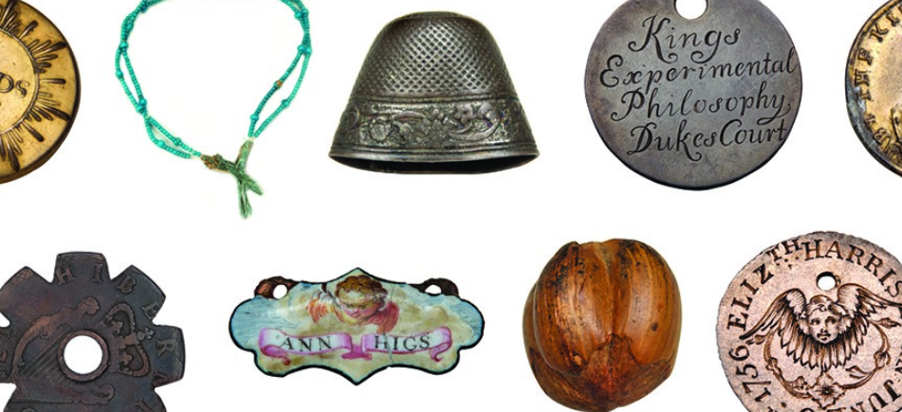
Foundling tokens – small objects left by mothers in the 18th century to identify their babies if reclaimed. Each holds a story of desperation, separation, hope and love. © Foundling Museum

COLLECTIONS & RESEARCH
Our collections are at the heart of how we tell the Museum’s story, shaping both public understanding and deeper research. Historic art and objects from the Foundling Hospital sit alongside the Gerald Coke Handel Collection and contemporary works by artists including Dame Tracey Emin, Michael Craig-Martin, Cornelia Parker, Sir Grayson Perry and Yinka Shonibare CBE.

The collections do more than preserve the past. They shape how stories of care for children, identity and belonging – told through art, music and words – are understood, shared and used in the present. Our exhibitions and displays support engagement and understanding, while research access and expertise strengthen the Museum’s role as a place of scholarship and cultural connection.

OUR LEARNING PROGRAMMES – DELIVERING SOCIAL IMPACT
Our learning programmes are shaped by one of the Museum’s founding ideas: that care and creativity belong together. We use culture to create practical opportunities for young people – especially those with experience of care – alongside support for early years development, family wellbeing and wider access and participation.

This work reflects what is distinctive about the Museum: we use culture not only to tell the story of care, but to respond to it in the present. Through sustained creative relationships, participants build confidence, develop skills, connect with others and find a sense of belonging in a cultural space where their stories and experiences are recognised and valued.

DEVELOPMENT OFFICE
The Museum is a charity with a strong and committed network of individual, trust and foundation supporters, as well as an engaged Chair and Board of Trustees. We are ambitious and entrepreneurial in our approach to fundraising, and this role will help strengthen one of our key areas of individual support.

Thanks to recent funding, the Museum has created a new Director of Development & Communications role to bring together how we raise support for the Museum with how we share our story, impact and ambition with supporters, stakeholders and the wider public. This role is part of that next phase, within a more joined-up, agile and ambitious Development and Communications function.

As part of this department, you will have the opportunity to help shape ways of working, contribute ideas and play an active role in building an effective and collaborative team culture.

HOW THE TEAM WORKS
The Development and Communications team is small, collaborative and ambitious. You will work closely with the Director of Development & Communications and colleagues across the Museum. The role offers unusual breadth – the chance to see how decisions are made, improve ways of working and shape activity from idea to delivery.

