**Role:** Director of Development

**Reporting to:** Museum Director

**Purpose of job:** The Director of Development is responsible for the fundraising activities of the Museum to generate income for the charity through individual giving, trusts and foundations, patrons, members, corporates, and partnerships. As part of the Senior Management Team, this strategic and operational role is key to ensuring that philanthropy and communications is understood as a vital part of our charitable impact across the Museum.

**Working pattern:** Full time (or 0.8 part time)

**Contract:** Permanent

**Salary:**  £65,000–£70,000 per annum FT (or PT 0.8 pro rata), depending on experience

**About the Foundling Museum**

A seaman, a composer and a painter, and the moving story of the charity they started 270 years ago. The Foundling Museum is a recipe of art and care, which still looks after kids today. Coram, Handel, Hogarth, what’s not to love? - Grayson Perry CBE, Foundling Museum Trustee   
  
Foundling Museum explores compelling stories of love, loss and care through art, music, writing and emotive objects.

The Museum is the UK’s only arts and heritage institution dedicated to the public understanding of lived experiences of care. Inspired by three great 18th-century activists - campaigner Thomas Coram, artist William Hogarth and composer George Frideric Handel - our mission is to inspire change and transform lives through the power of the arts. We believe in creative action that brings past and present together, to stimulate imaginations and enrich lives.  
  
The Foundling is also the birthplace of creative philanthropy – combining art and fundraising to publicly support lived experiences of care. At the Foundling, the term ‘care’ refers to children’s social care, including foster care, adoption, kinship care, local authority care and children’s homes. Central to our work is well-being through exhibitions, events, collections, research and arts programmes with care leavers, looked-after children, and early years (birth to five years old).

For an overview of our charitable activities and relationships with funders, please view the [Foundling Museum Annual Report 2024/2025 on this link.](https://foundlingmuseum.org.uk/wp-content/uploads/2025/01/The-Foundling-Museum-signed-audited-accounts-2023-2024.pdf)

**Role Overview**

The Director of Development at the Foundling Museum will lead the Museum’s fundraising strategy, driving income generation to support its mission and programmes. This senior leadership role oversees all aspects of fundraising, including corporate sponsorship, individual giving, trusts and foundations, membership schemes, philanthropic campaigns and communications.

The Director of Development works closely with the Museum's Director (CEO & Artistic Director), Trustees and key stakeholders to cultivate relationships with high-value donors, build strategic partnerships and secure sustainable financial support. As part of the Senior Management Team, this new role will work in collaboration with the Director of Finance (PT) and Director of Commercial and Operations (FT).

Reporting directly to the Museum Director, the role involves managing a small development team (2FTE) and communications team, setting ambitious targets and achieving actual income goals, ensuring alignment with the Museum’s values and strategic priorities.  

The Director of Development will play a critical role in shaping the Museum’s long-term financial resilience, leveraging the Museum’s reputation and impact to inspire and engage supporters from diverse sectors.

**Key duties**

Strategic Leadership

* Develop and implement a comprehensive fundraising, membership and partnership strategy to support the Museum’s short and long-term goals
* Work closely with senior leadership and the Board to align fundraising priorities with the Museum’s mission and strategic objectives

Fundraising

* Lead efforts to secure major gifts and corporate sponsorships, with a particular focus on individuals, trust and foundations, and corporates
* Oversee the development of compelling proposals, pitches, and presentations to corporate and individual supporters, including negotiation of corporate and philanthropic agreements
* Work with trusts, foundations, and statutory funding bodies to secure grants that support the Museum’s exhibitions, programmes and capital projects, ensuring timely and accurate reporting on all grant-funded activities
* Ensure that proper due diligence around potential donors is conducted in line with the organisation’s policies and compliant with the Fundraising Code of Practice of the Fundraising Regulator and other national bodies with which the Museum is registered

Donor and Partnership Development

* Identify, cultivate and secure new high-value donors of all types, including individuals, corporate partners, trusts and foundations and statutory funders
* Develop strong professional relationships with the Museum’s existing donors in a warm and personal atmosphere and in alignment with the Museum’s values
* Strengthen existing relationships with key stakeholders, including internal colleagues and board and committee members, to harness their relationships and foster a culture of philanthropy and understanding of fundraising across the organisation
* With the Director of Commercial and Operations, plan and deliver all major Museum events for key stakeholders
* Lead the team to cultivate the membership base of the Museum

Leadership & Team Management

* Manage the fundraising team, providing guidance and support to ensure success in meeting income targets
* Manage the communications team to oversee the brand, marketing, media communications and related budgets
* Oversee digital communications, including website and social media, to increase income generation, philanthropy and partnerships
* Foster a collaborative and results-driven culture within the team, and with SMT across the staff

Financial & Administrative Oversight

* Monitor and evaluate the effectiveness of fundraising activities, ensuring that targets are met and that funds are raised in line with the Museum's mission
* Oversee the fundraising budget and ensure efficient use of resources
* Liaise with the Director of Finance to ensure fundraising revenues are accurately tracked and accounted for
* Ensure complete, accurate and timely processes are conducted around all fundraising activity, including gift administration and acknowledgement, Gift Aid, GDPR compliance, etc.
* Provide regular reports to the Museum Director and Board of Trustees on the Museum’s progress on key projects and targets as articulated in the Museum’s strategic plan

Public Relations & Advocacy

* Serve as a key ambassador for the Museum, deputising for the Director where appropriate regarding income generation, enhancing its public profile and strengthening its reputation in the philanthropic and corporate sectors
* Represent the Foundling Museum at events, donor meetings and public forums
* Keep up to date on best practice in cultural fundraising and charity sector fundraising and communications, and bring this knowledge back for institutional benefit

**Person Specification**

Experience (required)

* Proven leadership, ideally at least 5 years, in a similar role where philanthropic and grant income is central to the success of the organisation
* Extensive experience of shaping and implementing fundraising strategies that have delivered a step change increase in actual income
* A substantial fundraising track record in securing income from diverse constituencies and across funding types, including personal experience in securing major gifts and managing teams to do the same
* A demonstrable history of innovation and entrepreneurial approaches to identifying income generation opportunities and pushing organisations forward to increase income
* Proven experience of nurturing long and short-term funding opportunities and being the key point of contact for both
* Significant team leadership experience of creating, leading, inspiring and motivating a high performing team and collaborating with a wide range of colleagues and stakeholders
* Strong performance management skills with a proven ability to develop, articulate and champion funding opportunities and gain buy-in among staff and key stakeholders, including board and committee members
* In-depth understanding of relevant UK charity and tax legislation, due diligence processes and policies relating to fundraising

Experience (desirable)

* Extensive experience of fundraising in arts and / or heritage, preferably in the UK
* Knowledge of effective fundraising in Europe and the US, including tax-effective giving
* Thorough understanding of Data Protection legislation as it relates to fundraising, marketing and communications
* Experience of effective endowment and legacy fundraising strategies

 Personal characteristics and skills (required)

* Ability to lead, motivate and inspire a fundraising and communications team
* Excellent written and oral communication skills
* Highly developed negotiation, influencing and persuasion skills
* A natural networker who builds confidence and trust and can represent the Foundling Museum at the highest levels and garner respect within peer networks
* Project management skills and ability to remove any organisational roadblocks that exist in relation to development
* Resilient, diplomatic and resourceful in solving problems
* Ability to prioritise and focus on the areas of greatest impact
* Commitment to the highest professional and ethical standards
* Strongly numerate with the ability to be entrepreneurial and take measured risks
* Alignment to the Foundling Museum’s values, communicating clearly, transparently and consistently; having accountability and working as part of a collaborative team towards a common purpose
* Enthusiasm and passion for the mission of the Foundling Museum and for the importance of increasing engagement with and access to the arts

**Conditions of Work and Benefits**

£65,000-70,000 full-time salary, depending on experience. We are open to 0.8 FTE at a pro-rata salary.

Probation period of 6 months, and notice period of 3 months (1 month during probation)  

This job will be based onsite at the Foundling Museum. For all our employees, there are opportunities for partial hybrid working if desired; we have an agreed minimum of 60% of working hours that must be onsite at the Museum.

Normal working hours are 9.30am to 5.30pm. This role requires some flexibility, including some mornings, evenings and weekends.

* 25 days annual leave per year (pro rata) + bank holidays (pro rata) + Birthday leave (one day)
* You will be eligible to join a group contributory pension scheme (3 months after your start date)
* Free access to our fully-funded Employee Assistance Programme for wellbeing – WISDOM
* Training support from our online learning platform
* Discount from the Foundling Museum Shop and local partner businesses
* Free or reduced-price access to partner museums
* Access to season ticket, rental deposit and cycle to work scheme loans (3 months from your start date)

Please also note that this job description will not form part of your contract or your terms and conditions of employment.  Duties and requirements of the role may vary from time to time in accordance with the needs of Foundling Museum, its strategy and the directions from the Museum Director. 

**Application timetable**

* Closing date for applications: 12 noon on Monday 20th October 2025
* First interview date:  Tuesday 4th and Wednesday 5th November 2025
* Second interview date for shortlisted candidates: Monday 10th November 2025

**How to apply**

To apply please follow this [link to our application portal](https://hr.breathehr.com/v/director-of-development-42873) where you will be asked to upload a completed copy of our standard application form and attach your CV by Monday 20th October. 

PLEASE NOTE: On the application portal, where it requests a CV, please ensure to upload your completed Application Form (required), your CV (optional) the Equal Opportunities Form (optional).

If invited to an interview, you will be asked to email your CV and Equal Oppurtunites form (optional) if you did not include these documents with your initial application via the portal.

Please get in touch with us if you have an access requirements or queries related to the application process via Diana Colinese (People Manager) [hr@foundlingmuseum.org.uk](mailto:hr@foundlingmuseum.org.uk) or +44 (0)20 7841 3600 (main switchboard)

If you wish to book a time to have a short informal conversation (phone or video) prior to application with the Museum Director please contact [directorsoffice@foundlingmuseum.org.uk](mailto:directorsoffice@foundlingmuseum.org.uk)

Please also note that any offer of employment will be subject to receipt of satisfactory references and proof of right to work in the UK and also may be subject to a DBS (Disclosure and Barring Service) check.   
 

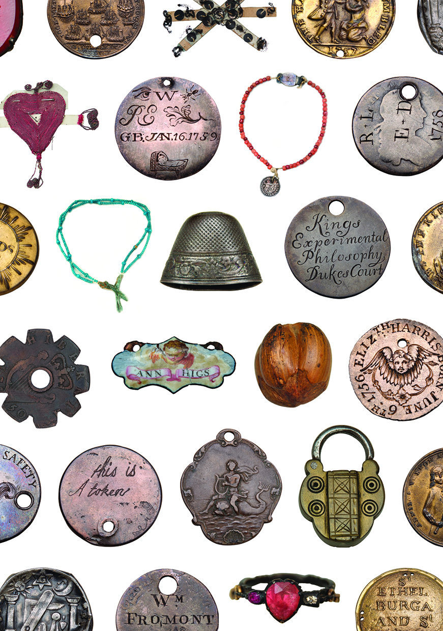

Tokens left by mothers with their babies in the eighteen century, as a means of identification. © Foundling Museum