**Role:** Assistant Venue Sales & Events Manager

**Reporting to:** Venue Sales & Events Manager

**Supervises:**  Events Duty Manager & Events Assistants (Part-Time & Sessional)

**Purpose of Job:** Assisting the Venue Sales and Events Manager and a small team to

maximise income from venue hire, supporting the vital work of the museum

**Working pattern**: Full time, hybrid - 35 hours per week, usually worked over 5 days

You will be expected to work some early mornings, evenings and weekends

TOIL is offered for working outside core office hours (Mon-Fri, 10-6pm)

Please note this is an office-based role, however we currently offer the option of hybrid working - staff can work up to 40% of their working week from home, providing responsibilities of the role are not impacted. This is subject to regular review and may change. Applicants should be able to attend work on site at short notice if required.

**Contract**: Permanent

**Salary**: £30,000–£32,000 per annum, depending on experience

**About the Foundling Museum**

*A seaman, a composer and a painter, and the moving story of the charity they started 270 years ago. The Foundling Museum is a recipe of art and care, which still looks after kids today. Coram, Handel, Hogarth, what’s not to love?* - Grayson Perry CBE, Foundling Museum Trustee   
  
**The Foundling Museum explores compelling stories of love, loss and care through art, music, writing and emotive objects.**

The Museum is the UK’s only arts and heritage institution dedicated to the public understanding of lived experiences of care. Inspired by three great 18th-century activists - campaigner Thomas Coram, artist William Hogarth and composer George Frideric Handel - our mission is to inspire change and transform lives through the power of the arts. We believe in creative action that brings past and present together, to stimulate imaginations and enrich lives.  
  
The Foundling is also the birthplace of creative philanthropy – combining art and fundraising to publicly support lived experiences of care. At the Foundling, the term ‘care’ refers to children’s social care, including foster care, adoption, kinship care, local authority care and children’s homes. Central to our work is well-being through exhibitions, events, collections, research and arts programmes with care leavers, looked-after children, and early years (birth to five years old).

Examples of our work include:

* Art projects which explore how our historic story of care still resonates today by addressing stigma and supporting mental health. We do this by working in a connected way, establishing collaborations with local health and community partners.
* ‘Tracing Our Tales’, our flagship training programme for care-experienced young people which was named Learning Programme of the Year at the 2022 Museums and Heritage Awards. Supported by our Learning Team, trainees learn art or creative writing skills in weekly sessions led by dynamic artists and poets, to build a creative portfolio.
* Exhibitions, collections and displays, ranging from tiny, touching identifying tokens left by mothers with their babies, to composer George Frideric Handel’s will. Around the Museum, you’ll find works of art by contemporary artists like Yinka Shonibare CBE RA, Tracey Emin and Michael Craig-Martin, as well as 18th-century artists William Hogarth, Thomas Gainsborough and Joshua Reynolds.

For an overview of our charitable activities, and relationships please view the [Foundling Museum Annual Report 2024/2025 on this link.](https://foundlingmuseum.org.uk/wp-content/uploads/2025/01/The-Foundling-Museum-signed-audited-accounts-2023-2024.pdf)

**Who we are looking for**

You will be enthusiastic, commercially astute, with excellent organisational skills and attention to detail. You will enjoy delivering exceptional, high-quality events through from concept to execution, putting customer service, safety and collection care at the heart of the process. You will be able to negotiate, plan and deliver income generating venue hires and other Museum events, all supporting the vital work of the Foundling Museum.

**Key Responsibilities & Objectives:**

* Respond promptly to event enquiries, prepare hire quotes and coordinate client site visits
* Assist in the planning and delivery of venue hires, ensuring events run smoothly and meet client expectations
* As a key part of the Venue Sales and Events team, you will help to grow the venue hire business to reach its targets (c.375k+ p/a) in 2025-26 and contribute to plans for increasing commercial income significantly over the next 5 years through venue hire
* You will attract, secure and deliver a diverse range of venue sales and events, upselling services and products, and by building relationships with our approved supplier list
* You will help to secure long-term financial sustainability for the Museum, ensuring commercial opportunities are aligned with the Museum’s flagship learning and cultural programme
* You will help ensure that all types of Museum event are safely planned and consistently managed

**Event Planning & Delivery:**

* Maintain the CRM database and diary management, ensuring that key dates are maximised – including liaising with internal colleagues to identify any diary clashes and work collaboratively with those teams
* Conduct site visits, ensuring that all opportunities to upsell are optimised
* Manage all processes around events administration, including logging all enquiries to our CRM, keeping the pipeline up to date, arranging contracts, organising invoicing and feedback forms, and ensuring all data is managed in line with GDPR and record-keeping standards
* Plan and support the delivery of all types of Foundling Museum events including venue hire, Museum private views, development events and the public programme
* Create clear, accurate and timely function sheets for all events ahead of delivery, including staff lists, emergency contacts, guest lists and equipment hire. Ensure these are circulated and understood by staff
* Act as Duty Event Manager for events outside of museum opening hours. This will include the scheduling, training and supervising of part-time and sessional event staff, subcontractors and suppliers
* Deliver consistent and confident briefings and debriefs, ensuring that all health and safety issues are considered and communicated as part of these
* Ensure health and safety procedures and risk assessments are requested and completed and adhered to during events, ensuring the safety and wellbeing of people attending and working, and of the collections

**Marketing and Sales:**

* Help develop and attract new revenue streams and clients, while maximising existing business opportunities, ensuring venue hire income reaches or exceeds agreed targets and KPIs
* Work and develop relationships with an approved supplier list, ensuring that invoices are processed and paid within agreed timeframes
* Contribute ideas and feedback to improve processes and client experience
* Update and maintain venue hire listings across third-party platforms (e.g. Hitched, VenueScanner etc).
* Gather and share testimonials, photography, and post-event feedback to help promote future sales
* Represent the Foundling Museum at tradeshows, and support with planning and hosting open days, showcases, networking and cultivation events

**Key relationships:**

* Work collaboratively and supportively with the Venue Sales & Events team and as part of the wider Museum team
* Support the Visitor Engagement, Public Programme, Philanthropy and Learning teams to plan and deliver all museum events in a consistent way
* Build and maintain excellent relationships with suppliers and other external stakeholders

**Person Specification**

**Essential:**

* Experience working within events or sales, ideally in a cultural setting
* Excellent administration, prioritisation and organisational skills
* Knowledge of the events industry
* Confident, personable and able to negotiate, network and build relationships
* Self-motivated, and able to work independently as well as within a team
* Willingness to work outside core office hours to manage morning, evening and weekend events
* Calm approach to pressurised situations and a genuine enjoyment of working at a fast pace and to tight deadlines, to see tasks through to completion
* An interest in the history and future of the Foundling Museum
* Able to act with discretion and maintain professional confidentiality at all times

**Desirable:**

* Database, CRM, room-booking system management aptitude and knowledge
* Experience in or interest in marketing, sales and social media
* Experience of working within a historic venue
* An interest in history and art
* Knowledge of and/or have a food hygiene qualification
* Experience writing or following risk assessments
* Experience issuing contracts and invoices
* Knowledge and interest in best practice for sustainable events

**Benefits:**

* 25 days annual leave per year (pro rata) + bank holidays (pro rata) + Birthday leave + Volunteering leave
* You will be eligible to join a group contributory pension scheme (3 months after your start date)
* Discount from the Foundling Museum Shop and local partner businesses
* Access to season ticket, rental deposit and cycle to work scheme loans (3 months from your start date)
* Free access to partner museums
* Free access to our fully funded Employee Assistance Programme for wellbeing – WISDOM
* Training support from our online learning platform

**Interview timetable**

**Closing date: Monday 22 September at 10am**

**Interview date: Tuesday 30 September**

**How to apply**

**To apply please follow this link** [https://hr.breathehr.com/v/assistant-venue-sales-events-42824](https://hr.breathehr.com/recruitment/vacancies/42824?identifier=thefoundlingmuseum) **to our application portal where you will be asked to upload a completed copy of our standard application form.**

On this application form you need to provide:

* Your contact details
* Details of relevant achievements in recent posts, as well as any relevant education and professional qualifications that are appropriate to the post
* Please also tell us what makes you a good fit for the role, for example, giving evidence of your ability to match the criteria outlined in the Person Specification
* Explain why you wish to work for us
* Details of your notice period and names of 2 referees, together with the capacity in which they have known you, and an indication of when in the process they can be contacted (please note we will not contact your referees without your express permission)

**PLEASE NOTE: the application portal will request a CV. This is not necessary and can be ignored. Where it requests a CV please only upload the completed application form, and the optional Equal Opportunities form (if you wish to submit one).**

Please get in touch with us via [HR@foundlingmuseum.org.uk](mailto:HR@foundlingmuseum.org.uk) you have any access requirements, for example if you would prefer to send your application via video.   
  
Any queries should also be directed to [HR@foundlingmuseum.org.uk](mailto:HR@foundlingmuseum.org.uk)

Please note that any offer of employment will be subject to receipt of satisfactory references and proof of right to work in the UK, and also may be subject to a DBS (Disclosure and Barring Service) check.

Please also note that this job description will not form part of your contract or your terms and conditions of employment.  Duties and requirements of the role may vary from time to time in accordance with the needs of Foundling Museum, its strategy and the directions from the Director.

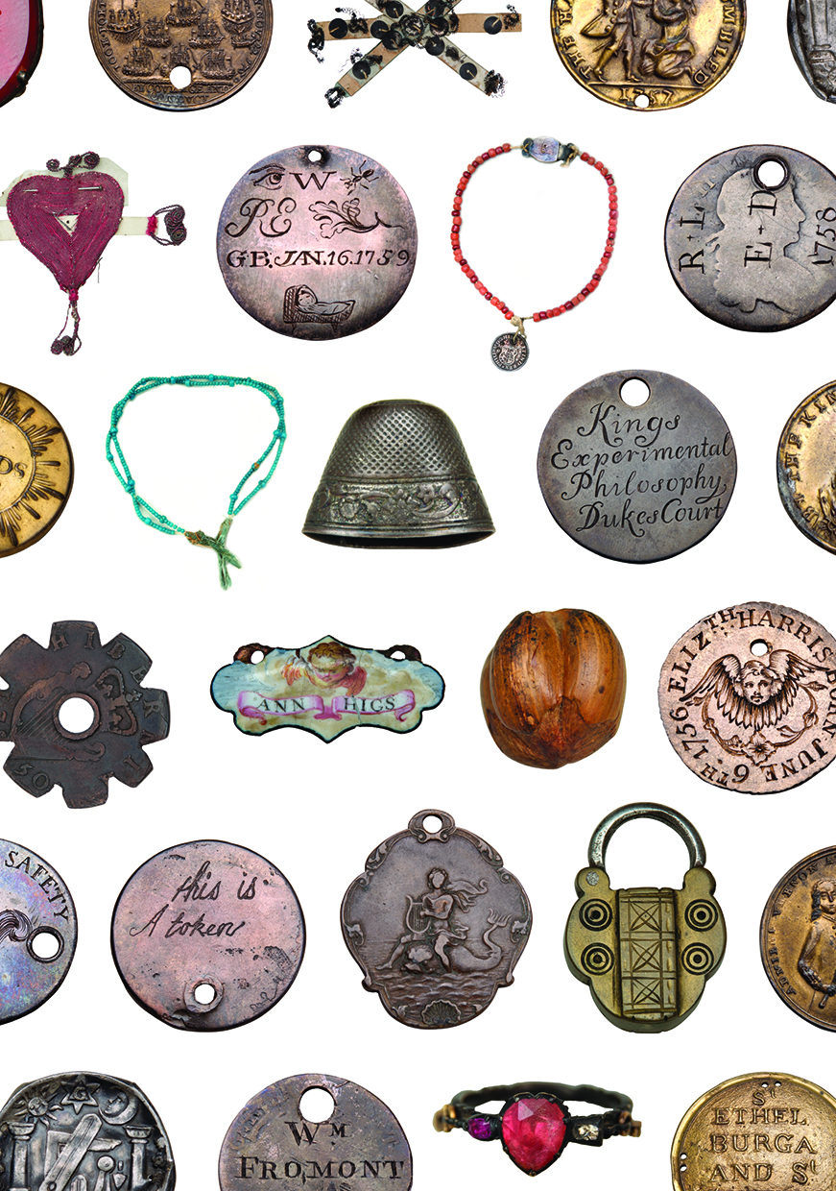

*Tokens left by mothers with their babies in the eighteen century, as a means of identification. © Foundling Museum*