**Role:** Finance & CRM Administrator

**Reporting to:** Financial Controller, with dotted line to the Directors/Fundraising team

**Purpose of Job:** To work with the Finance and Fundraising teams to provide excellent finance, CRM & other systems administration. This will support income generation, research, data capture and information security throughout the Museum. Responsibilities include maintaining financial records, managing and maintaining a CRM database of contacts, supporting other digital systems, and some general administrative duties including IT support.

**Working pattern**: **35 hours per week,**usually worked from 10 – 6pm.**Flexible/hybrid working offered for up 40% of hours to be worked from home.**

**Contract**: Permanent

**Salary**: £28,000–£30,000 per annum, depending on experience

**About the Foundling Museum**

*A seaman, a composer and a painter, and the moving story of the charity they started 270 years ago. The Foundling Museum is a recipe of art and care, which still looks after kids today. Coram, Handel, Hogarth, what’s not to love?* - Grayson Perry CBE, Foundling Museum Trustee   
  
**The Foundling Museum explores compelling stories of love, loss and care through art, music, writing and emotive objects.**

The Museum is the UK’s only arts and heritage institution dedicated to the public understanding of lived experiences of care. Inspired by three great 18th-century activists - campaigner Thomas Coram, artist William Hogarth and composer George Frideric Handel - our mission is to inspire change and transform lives through the power of the arts. We believe in creative action that brings past and present together, to stimulate imaginations and enrich lives.  
  
The Foundling is also the birthplace of creative philanthropy – combining art and fundraising to publicly support lived experiences of care. At the Foundling, the term ‘care’ refers to children’s social care, including foster care, adoption, kinship care, local authority care and children’s homes. Central to our work is well-being through exhibitions, events, collections, research and arts programmes with care leavers, looked-after children, and early years (birth to five years old).

Examples of our work include:

* Art projects which explore how our historic story of care still resonates today by addressing stigma and supporting mental health. We do this by working in a connected way, establishing collaborations with local health and community partners.
* ‘Tracing Our Tales’, our flagship training programme for care-experienced young people which was named Learning Programme of the Year at the 2022 Museums and Heritage Awards. Supported by our Learning Team, trainees learn art or creative writing skills in weekly sessions led by dynamic artists and poets, to build a creative portfolio.
* Exhibitions, collections and displays, ranging from tiny, touching identifying tokens left by mothers with their babies, to composer George Frideric Handel’s will. Around the Museum, you’ll find works of art by contemporary artists like Yinka Shonibare CBE RA, Tracey Emin and Michael Craig-Martin, as well as 18th-century artists William Hogarth, Thomas Gainsborough and Joshua Reynolds.

For an overview of our charitable activities and relationships please view the [Foundling Museum Annual Report 2024/2025 on this link.](https://foundlingmuseum.org.uk/wp-content/uploads/2025/01/The-Foundling-Museum-signed-audited-accounts-2023-2024.pdf)

**Who we are looking for**

Are you fascinated by data with an excellent grasp on finance, IT and digital systems? Are you interested in the role financial, CRM and other digital systems play in how arts organisations and cultural projects are managed? Are you looking to take the next step in your arts finance, administration or fundraising career?

The Foundling Museum is transforming how digital systems underpin the foundations of this small but mighty Museum and charity. The position of Finance & CRM Administrator sits at the heart of this continued transition, following the successful implementation and migration to Shopify, Xero & Beacon CRM which began in 2023.

This new role is essential to the success of the Finance and Fundraising teams, in providing effective finance and CRM administration support. The Finance & CRM Administrator will support income generation activities including fundraising and venue hire, as well as playing a vital role in keeping the Museum’s accounting systems working effectively.

This includes processing all types of financial transactions on Xero and maintaining records on Beacon. You will work as a key part of both teams supporting the Museum’s strategy through the provision of high quality financial and other data, and the maintenance of the underlying systems.  
This is an exciting opportunity for a highly organised individual with strong financial skills, an attention to detail, and a flair for collaborative working and information management. You will be looking to expand your skillset and make a tangible impact on our work, through the effective use and development of the main systems underpinning our financial strategy and income generation.

**Key objectives**

* Supporting the Finance team with accurate and timely processing and reconciling of all types of Museum transactions and ledgers including sales, purchases, banking and cash.
* Continue ongoing migration of supporter and customer data to Beacon CRM, working with all teams
* Support all staff with SharePoint migration project ensuring effective record management
* Continue seeking opportunities to improve the use of our digital systems to increase organisational efficiencies and income generation

**Key responsibilities**

**Finance**

* Raise sales invoices
* Process credit card transactions
* Credit control and reconciliation of the sales ledger
* Financial management of shop takings
* Process bank and cash transactions
* Bank reconciliations
* Produce financial reports and other ad hoc duties as required by the Financial Controller
* Gift Aid Claims support
* Training in and promoting use of XERO to staff

**CRM Administration**

* Maintain and update Beacon with all fundraising transactions including applications, prospects, and funding receipts
* Process donations, pledges and ticket payments from individuals, organisations, trusts and foundations
* Day-to-day administration of the Museum’s Friends and other membership schemes
* Maintain up-to-date and accurate records of contacts ensuring that strict confidentiality and GDPR legislation and guidance is adhered to
* Monitor data quality by regularly creating and executing processes to cleanse and standardise data in the CRM
* Lead on development of improving existing CRM systems within Beacon CRM
* Assist in data capture and gathering to support fundraising compliance and applications
* Training in and promoting use of CRM to staff including building reports.

**Admin support**

* Basic IT support working with outsourced IT contractors and the Operations team
* Manage the ordering of office items
* Facilitate the use, internal awareness and confidence with digital systems, creating and managing logins
* Supporting the Director’s Office Project Manager with governance and meetings

**Other**

* To perform any other tasks as reasonably requested by the Directors, Financial Controller and Fundraising team

**Person specification**

**Essential:**

* Excellent financial, administration and analytical skills
* Experience of financial systems such as Xero, Sage or QuickBooks
* Good understanding and experience of Excel
* Excellent interpersonal skills and the ability to communicate effectively in writing, over the phone, and face-to-face with the Museum’s different stakeholders
* Solid experience working with not-for-profit databases, such as Beacon CRM
* The ability to also work independently and take initiative within a small team
* Proven, excellent organisational skills, with close attention to detail, the ability to multi-task and prioritise responsibilities
* Excellent IT skills including in depth knowledge of financial systems, CRM, Microsoft 365, SharePoint, and other cloud based digital systems
* An enjoyment of and willingness to engage with a wide variety of people and organisations
* Able to act with discretion and maintain professional confidentiality at all times
* Appreciation of and support for the aims, values and ethos of The Foundling Museum

**Desirable:**

* An interest in and engagement with the work and ethos of the Museum
* An interest in and engagement with the arts, heritage and/or music
* Experience of working in a finance or fundraising environment

**Benefits:**

* 25 days annual leave per year (pro rata) + bank holidays (pro rata) + Birthday leave + Volunteering leave
* You will be eligible to join a group contributory pension scheme (3 months after your start date)
* Discount from the Foundling Museum Shop and local partner businesses
* Access to season ticket, rental deposit and cycle to work scheme loans (3 months from your start date)
* Free and discounted access to partner museums and galleries
* Free access to our fully funded Employee Assistance Programme for wellbeing – WISDOM
* Training support from our online learning platform

**Interview timetable**

**Closing date: Wednesday 1 October at 5pm**

**First interview date: 7 and 8 October 2025**(Please note that the interview will include a job-related task)  
**Second interview date for shortlisted candidates: 13 or 14 October 2025**

**How to apply**

**To apply please follow the link on the webpage to our application portal where you will be asked to upload a completed copy of our standard application form.**

On this application form you need to provide:

* Your contact details
* Details of relevant achievements in recent posts, as well as any relevant education and professional qualifications that are appropriate to the post
* Please also tell us what makes you a good fit for the role, for example, giving evidence of your ability to match the criteria outlined in the Person Specification
* Explain why you wish to work for us
* Details of your notice period and names of 2 referees, together with the capacity in which they have known you, and an indication of when in the process they can be contacted (please note we will not contact your referees without your express permission)

**PLEASE NOTE: the application portal will request a CV. This is not necessary and can be ignored. Where it requests a CV please only upload the completed application form, and the optional Equal Opportunities form (if you wish to submit one).**

Please get in touch with us via [HR@foundlingmuseum.org.uk](mailto:HR@foundlingmuseum.org.uk) you have any access requirements, for example if you would prefer to send your application via video.   
  
Any queries should also be directed to [HR@foundlingmuseum.org.uk](mailto:HR@foundlingmuseum.org.uk)

Please note that any offer of employment will be subject to receipt of satisfactory references and proof of right to work in the UK, and also may be subject to a DBS (Disclosure and Barring Service) check.

Please also note that this job description will not form part of your contract or your terms and conditions of employment.  Duties and requirements of the role may vary from time to time in accordance with the needs of Foundling Museum, its strategy and the directions from the Director.

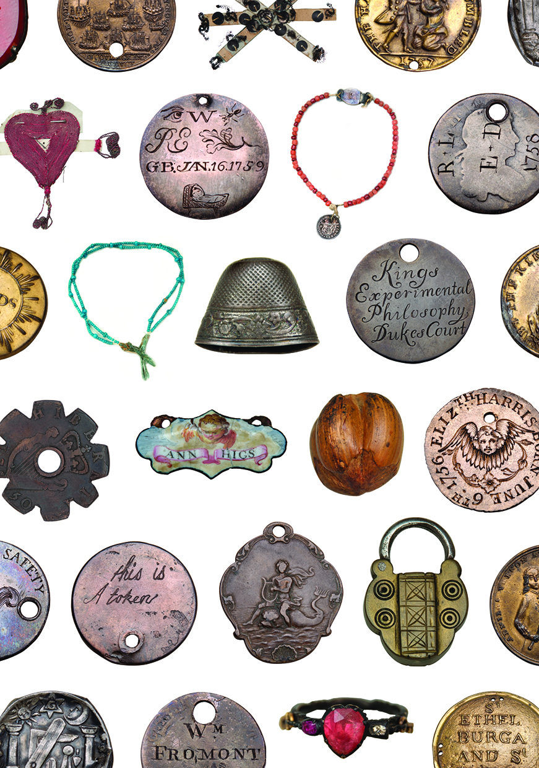

*Tokens left by mothers with their babies in the eighteenth century, as a means of identification. © Foundling Museum*