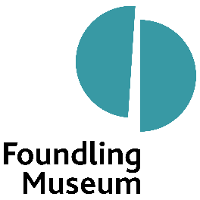

|  |  |
| --- | --- |
| **Role:** | Museum Assistant (Career Development) |
| **Reporting to:** | Visitor Engagement Manager, with pastoral support mentor Curator: Artists’ Projects |
| **Purpose of job:** | To help ensure the effective and successful delivery of all visitor-facing services at the Museum, while supporting and contributing to other departments such as Communications, Curatorial, Events and Operations |
| **Working pattern:** | Full time (09:30-17:30) |
| **Contract:** | Fixed term, 1-year placement |
| **Salary:** | £23,993 |
| **Eligibility:** | Care leavers aged 18-24, currently living in the London boroughs of Barnet, Camden, Harrow, Brent, Kensington & Chelsea, Ealing, Westminster or Hammersmith & Fulham |

**About Foundling Museum**

Foundling Museum is the only cultural institution in the UK to celebrate people who have been in care, and those who care for them.

Foundling Museum is a contemporary museum established in 2004, with collections of art, music, writing and emotive objects that stretch back to the 18th century. Our work grows from our unique foundations, as the only Foundling Hospital museum in the world that has an art collection donated by artists, and the only one to tell the story of the birth of creative philanthropy.

The Museum shows how artists championed the Foundling cause, including artist William Hogarth and composer George Frideric Handel. Their compassion and generosity demonstrated that the arts transform lives. Foundling Museum works with outstanding contemporary artists, writers and musicians to ensure that leading creatives continue to be part of the story of care.

At the heart of our work is our award-winning arts training programme for young care leavers, professional development opportunities for care leavers, and arts and wellbeing activities for children and families.

Examples of our work include:

Art projects which explore how our historic story of care still resonates today by addressing stigma and through mental health support. We do this by working in a connected way, establishing collaborations with local health and community partners.

‘Tracing Our Tales’, our flagship training programme for care-experienced young people which was named Learning Programme of the Year at the 2022 Museums and Heritage Awards. Supported by our Learning team, trainees learn art or creative writing skills in weekly sessions led by dynamic artists and poets, to build a creative portfolio.

Exhibitions, collections and displays, ranging from tiny, touching identifying tokens left by mothers with their babies, to composer George Frideric Handel’s will. Around the Museum you’ll find works of art by contemporary artists like Yinka Shonibare CBE RA, Tracey Emin and Michael Craig-Martin, as well as 18th-century artists like William Hogarth, Thomas Gainsborough and Joshua Reynolds.

This is an exciting time to join the Museum, which has recently secured Arts Council England National Portfolio Organisation funding for 2023-26, and is delivering on ambitious plans to secure its long-term future.

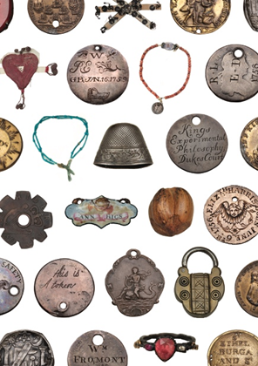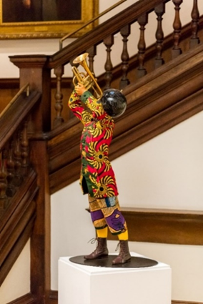

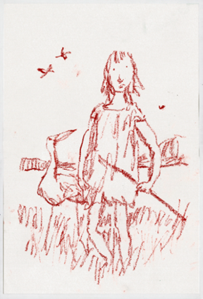

Images: Quentin Blake, from *Children with Birds and Dogs*, 2019 (left), donated by the artist, and Yinka Shonibare CBE RA, *Trumpet Boy*, 2010 (centre), shown as part of Cornelia Parker’s exhibition *FOUND* in 2016 and acquired with support from Art Fund, the ACE/V&A Collection Purchase Grant and individual supporters. © The artists. Tokens left by mothers with their babies at the Foundling Hospital in the 18th century, as a means of identification (right) © Foundling Museum.

**Who we are looking for**

We’re looking for a committed, enthusiastic, friendly and reliable team player, to work across key departments at Foundling Museum in this Museum Assistant (Career Development) placement. Over the course of 12 months, you’ll gain the skills, confidence and experience needed to follow a career in the arts and heritage sector.

Alongside working in the Museum, this placement comes with the opportunity to complete professional development training, including attending industry masterclasses, seminars and workshops, and cultivating personal skills in areas like public speaking, first aid and project management.

You will work mainly alongside the Visitor Engagement team, who welcome, look after and provide information to visitors, run the shop, sell tickets, and support our volunteers. This work would ideally suit someone who is friendly and willing to talk to people of all ages. Training will be given to develop public speaking skills and self-confidence. You will also help with the shop, including with administrative tasks, assisting in retail projects and working on the till.

As well as working day-to-day with the Visitor Engagement team, you will spend time with each of the following teams: Marketing and Communications, Learning and Community Engagement, Curatorial, Public Programming and Events. You will not only gain experience supporting and contributing to these department’s areas, but you will also have an opportunity to complete creative and business development projects. These include working on interpretation with a view to curating your own display, and in developing the Museum’s retail offers.

Along with gaining skills and experience in various Museum departments, the final three months of the placement will be spent in the department of your choosing. This will enable you to deepen your knowledge and create a solid foundation on which to build a future career in the arts and heritage sector.

Throughout the placement you will be able to access a variety of career development opportunities, ranging from CV writing to job application and interview techniques, coaching and mentoring.

Once the placement is finished you will have the opportunity to join our team of employed sessional staff working front of house and for venue hire events.

**Key responsibilities**

This post will provide you with the opportunity to work across several teams, each with a diverse range of responsibilities.

Examples of how you will work across these teams are below. Please be aware that you do not need to have any previous experience in these areas, as training and supervision will be provided.

**Visitor Engagement**

* Help the Visitor Engagement team deliver a high standard of service, which includes being a friendly face greeting and giving information to visitors when they first arrive
* Assist the Visitor Engagement Manager with the volunteers, making sure they get the correct breaks according to the rota each day and covering any absences
* Ensure volunteers have the information they need to do their jobs and to talk confidently about the Museum to the public
* Promote the Museum’s activities, exhibitions, displays and events, and ensure that Health and Safety and evacuation procedures are clear to visitors, volunteers and staff
* Help restock the Museum shop and assist with reordering items that are selling well
* Contribute towards retail development projects, such as suggesting and researching new products to develop, looking at pricing and sustainability
* Be flexible in approach and undertake all duties given by the Visitor Engagement Manager

**Marketing and Communications**

* Carry out visitor surveys which help develop the current audience strategy
* Support efforts to grow the Museum’s audiences, particularly those who are harder to reach
* Provide a fresh pair of eyes on the Museum’s content across social media, our website and a new creative web-portal for care-experienced people
* Help to create content for social media and our website

**Learning and Community Engagement**

* Work with the care-experienced Tracing Our Tales trainees, assisting with the set up and the preparations for workshops, and helping them create live and pre-recorded activities
* Assist with the research for the new creative web-portal for care-experienced people
* Aid the Curator: Artists’ Projects in the recruitment of new care leavers for the Tracing Our Tales trainee programme and the evaluation of the programme
* Assist with family workshops, including set-up/tidy-up, evaluation, advertising and gathering content for social media
* Contribute to the Museum’s staff diversity, inclusion and access group
* Assist with the Early Years project, preparing for workshops and monitoring materials
* Support the Early Years artists during delivery of workshops in schools and Early Years settings

**Curatorial (3-month placement)**

* Help care for the Museum’s collection of art and objects, including monitoring and controlling pests that can damage objects, and conservation cleaning
* Assist with collections checks, including handling art and objects and accurately documenting them
* Shadow the Museum’s conservation experts
* Help with the development and delivery of exhibitions and displays, including assisting with exhibition and display administration (e.g. preparing information labels), and shadowing and supporting the exhibition team through the installation process

**Events and Operations**

* Assist with the organisation of Museum events (e.g. concerts, talks and film screenings) by setting up rooms for the events and making sure the volunteers are well-informed
* Support the Events team with the delivery of venue hires and events, including assisting with room set-ups, pack-downs and tea and coffee making
* Support the Operations team with exhibition installations and de-installations, including redecoration of spaces
* Support with Health and Safety, such as helping with the communication of safety processes to visitors, hirers and participants, and keeping first aid kits topped up
* Contribute towards the Staff Sustainability Action Group to ensure the Museum operates as sustainably as possible

**Person Specification**

* Reliable and hardworking – able to turn up on time and complete tasks independently
* Good at working with the public in a customer service role
* Interested in working in a museum, a heritage attraction or in the arts
* Organised and confident – able to help volunteers to understand their daily responsibilities, respond to enquiries on the phone and by email, and talk to individuals from a variety of backgrounds
* Commitment to the role
* Able to use Microsoft Office (Word, Excel, and Outlook)
* Team player who looks out for the rest of the team and offers support wherever it is needed

**If you have any of this experience, be sure to highlight it in your application:**

* Appreciation of accessibility and inclusion
* Experience of working with volunteers
* Experience of working in a customer service role (retail or hospitality work)
* Experience of using a till system
* Experience of creating or editing videos
* Knowledge of risk assessments and Health and Safety issues
* A working understanding and commitment to equal opportunities

**Benefits**

* 25 days annual holiday plus bank holidays (pro rata for part-time staff)
* You will be eligible to join a group contributory pension scheme 3 months after your start date
* Discount from the Foundling Museum shop and local partner businesses
* Access to season ticket, rental deposit and cycle to work scheme loans 3 months after your start date
* Free access to partner museums
* Free access to our fully funded Employee Assistance Programme for wellbeing, WISDOM
* Training support from our online learning platforms

**Equal Opportunities**

We actively welcome Black, Asian, ethnically diverse and disabled applicants and value the positive impact that diversity has on our teams. We encourage applications from all backgrounds and identities and are committed to having a team that is made up of diverse skills, experiences and abilities. We are committed to equality and diversity within our workforce and all opportunities provided by Foundling Museum.

We will make all reasonable adjustments so that if you have a disability it puts you at no disadvantage throughout the selection process. Please contact us on 02078413600 and ask for the Learning team if you require access support for your application (e.g. you wish to apply by video).

If you are invited to interview, please let us know what reasonable adjustments you require.

**To Apply**

If you would like to have an informal chat about this opportunity please email learning@foundlingmuseum.org.uk.

To apply please download the application form from our website and then follow the link to our application portal, where you will be asked to upload your completed application form. If you have any questions please contact hr@foundlingmuseum.org.uk.

If you wish to, you may also complete and upload an equal opportunity monitoring form, (which can also be downloaded from our website). This will be separated from your application and is used by us to help monitor our commitment to Equality, Diversity and Inclusion as outlined above.

Please note that as part of our commitment to safeguarding our employees, volunteers and service users we may require you to undergo a DBS check as part of our recruitment process and all employees are subject to ‘right to work in the UK’ checks.

**Closing Date** Monday 17 February 2025 at 12 noon

**Interviews** Week commencing Monday 24 February 2025

This post has been made possible with funding from John Lyon’s Charity.