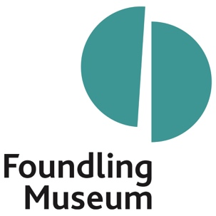

Role: | Families Arts Manager
Reporting to: | Curator, Artists Projects
Purpose of job: | To support the strategic ambitions of the Foundling Museum, by the development and delivery of the Families Arts programme across a range of locations, building relationships with artists and partners.
Working pattern: | Part time: 0.4 of full time, pro rata from 35 hours per week
Contract: | Fixed term, 2 years
Salary: | £32,130 (pro rata)
To apply: | To apply please follow this link

About the Foundling Museum
‘A seaman, a composer and a painter, and the moving story of the charity they started 270 years ago. It is a recipe of art and care, which still looks after kids today. Coram, Handel, Hogarth, what’s not to love?’ - Grayson Perry CBE, Foundling Museum Trustee

The Foundling Museum tells the compelling story of Thomas Coram’s Hospital for foundlings, the UK’s first ever children’s charity, now named Coram, and its first public art gallery, now the Foundling Museum.

Inspired by three great 18th-century activists - Thomas Coram, William Hogarth and George Frideric Handel - our mission is to inspire change and transform lives through the power of the arts. We believe in creative action that brings past and present together, to stimulate imaginations and enrich lives.

Examples of our work include:
- ‘Tracing Our Tales’, our flagship training programme for care-experienced young people which was named Learning Programme of the Year at the 2022 Museums and Heritage Awards. Supported by our Learning Team, trainees learn art or creative writing skills in weekly sessions led by dynamic artists and poets, to build a creative portfolio.
- Exhibitions, collections and displays, ranging from tiny, touching identifying tokens left by mothers with their babies, to composer George Frideric Handel’s will. Around the Museum, you’ll find works of art by contemporary artists like Yinka Shonibare CBE RA, Tracey Emin and Michael Craig-Martin, as well as 18th-century artists William Hogarth, Thomas Gainsborough and Joshua Reynolds.
- Art projects which explore how our historic story of care still resonates today by addressing stigma and supporting mental health. We do this by working in a connected way, establishing collaborations with local health and community partners.
This is an exciting time to join the Museum, which has recently secured Arts Council England National Portfolio Organisation funding for 2023-26, and is delivering on ambitious plans to secure its long-term future.

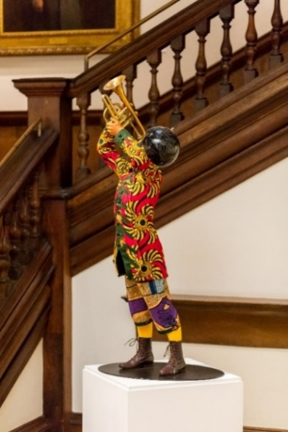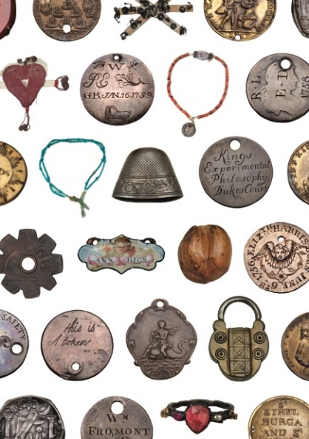
Images: Quentin Blake, from Children with Birds and Dogs, 2019 (left), donated by the artist and Yinka Shonibare CBE RA, Trumpet Boy, 2010 (right), shown as part of Cornelia Parker’s exhibition FOUND in 2016 and acquired with support from Art Fund, the ACE/V&A Collection Purchase Grant and individual supporters. © The artists. Tokens left by mothers with their babies at the Foundling Hospital in the 18th century, as a means of identification © Foundling Museum

Who we are looking for
You will be experienced in developing and delivering learning programmes for families, in partnership with a museum or other arts organisation. Creative, highly-organized and self-motivated, you will deliver innovative and impactful projects across a range of sites (including at the Museum, across London Boroughs and in Stoke-On-Trent) and demonstrate their excellence through evaluation. You will keep all records relating to your projects, ensuring that the Museum’s policies and processes are adhered to and that your programmes are delivered to time and budget. You will bring your own ideas but will also be willing to collaborate with others, working with colleagues across the museum. You will manage and support the work of artists and volunteers. You will manage the evaluation and reporting of all Families programmes, allowing us to demonstrate excellence to current and future funders, including the Arts Council.

While Families programming will be your main focus, you will be willing to work flexibly across the Museum’s Learning programmes, supporting the work of the Curator: Artist’s Projects & Participation. Where relevant, you will also contribute to discussions around future programme and strategy. In all you do, you will champion inclusion and accessibility and will be an ambassador for the Museum.

Key duties

- Develop and deliver learning projects inspired by the story of the Foundling Hospital and the Museum’s Collection
- Manage and develop ambitious projects and programmes, in response to existing commitments and new opportunities. This includes projects at the Museum and in Camden, Newham, Dagenham and Barking, and Stoke on Trent.
- Manage short term family projects with local community groups.
- Contribute to or commission family content for the Museum’s digital channels
- Create or commission exciting self-directed art activities for the museum displays and exhibitions
- Work closely and collaboratively with the Early Years Manager and Curator: Artists’ Projects and Participation.
- Lead on the development of trails around the Museum for families and young people
- Develop existing partnerships and relationships with children, families, artists, workshop facilitators and partners
- Oversee evaluation and reporting of all Family projects.
- Adhere to the highest standards of Safeguarding and other ethical policies within your own role and keep up to date with any training
- Work with the Communications team to promote family programming
- Contribute to funding applications and provide the Development Team with evaluation and reporting needed for successful funding bids.
- Contribute to financial planning within the Learning Department and manage substantial budgets.
- Develop processes for and oversee the delivery of evaluation.
- Maintain all records and documentation relating to Family projects.
- Assist with the development and delivery of other Learning programmes as needed.

Person specification
Essential
- Experience of developing and programming creative projects that respond to a museum or other creative institution’s story and collections.
- Up-to-date knowledge of good practice in Museum learning.
- Proactive self-starter with a collaborative, generous approach.
- Commitment to inclusion and ability to communicate with people from all walks of life.
- Knowledge of safeguarding policies and risk assessments relating to Families.
- Experience of managing projects within community settings.
- Experience of managing budgets and of working within the constraints of tight deadlines.
- Experience of supervising artists or other creative professionals.
- Excellent IT skills.
- Up-to-date Enhanced DBS Check or willingness to complete such a check.
- Eligible to work in the UK.

Desirable
- Knowledge of the National Curriculum
- Degree, apprenticeship or relevant experience in a related subject.
- Experience of project evaluation or of working with an external evaluator
- Experience of project management

Benefits
- 25 days annual leave per year (pro rata) + bank holidays (pro rata)
- You will be eligible to join a group contributory pension scheme 3 months after your start date
- Discount from the Foundling Museum Shop and local partner businesses

Interview timetable & how to apply

Closing date: 3 June
First interview date: TBC

To apply please follow this link to our application portal where you will be asked to upload:
- A comprehensive CV* with full employment history, giving details of relevant achievements in recent posts, as well as any relevant education and professional qualifications that are appropriate to the post
- A covering letter* that clearly states why you are interested in this post. Please also tell us what makes you a good fit for the role, for example, giving evidence of your ability to match the criteria outlined in the Person Specification
- Details of your notice period and names of 2 referees, together with a brief statement of the capacity in which they have known you, and an indication of when in the process they can be contacted (please note we will not contact your referees without your express permission)
- Telephone numbers (preferably daytime and evening/mobile), which will be used with discretion
*Please get in touch if you would prefer to send your CV and cover letter via video application

Please note that any offer of employment will be subject to an Enhanced DBS (Disclosure and Barring Service) check and two references.

