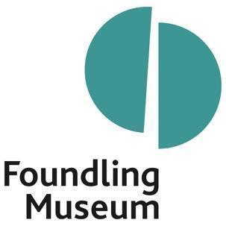

| **Museum Assistant (Career Development) Application Form** | |
| --- | --- |
| **Personal Information**  Please fill out all the fields below | |
| Name |  |
| Home address |  |
| Telephone number |  |
| E-mail address |  |
| Will you be aged between 18 – 24, 1st February 2024? |  |
| Which borough do you live in? |  |
| Please tell us why you would like to be our next Museum Assistant |  |
| Please tell us about your interest in museums and the arts |  |
| Please tell us what skills you will bring to the role of Museum Assistant. These skills can be gained from any experience. |  |
| When can you start? |  |
| Please list any relevant qualifications to the role – these might be GSCEs, NVQs, A Levels etc. We will also consider applicants with no formal qualifications. |  |
| Please tell us about any of your hobbies and interests or clubs you belong to |  |

| **References**    Please provide details of two references who can provide a reference for you – these can be from a past teacher, employer or social worker or other adult who can comment on your skills and suitability for the role. | |
| --- | --- |
| **Reference 1** |  |
| **Name** |  |
| **Email address** |  |
| **Relationship to you (e.g., teacher, employer etc)** |  |
| **Reference 2** |  |
| **Name** |  |
| **Email address** |  |
| **Relationship to you (e.g., teacher, employer)** |  |